|  |  |
| --- | --- |
| Assignment Date | 23 September 2022 |
| Student Name | DEEPTHI SHERONA A |
| Student Roll Number | 61771921008 |
| Maximum Marks | 2 Marks |

**Question-1:**

Split the String

s = "Hi there Sam!"

# Solution:

s.split()

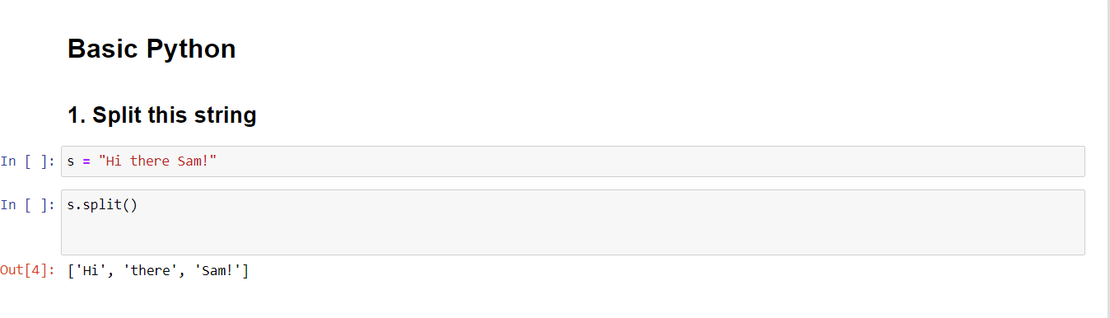

**Question-2:**

Use .format() to print the following String

Output should be: The Diameter of Earth is 12742 Kilometers

# Solution :

planet = "Earth" diameter = 12742

print('The diameter of {} is {} kilometers.' . format(planet,diameter));

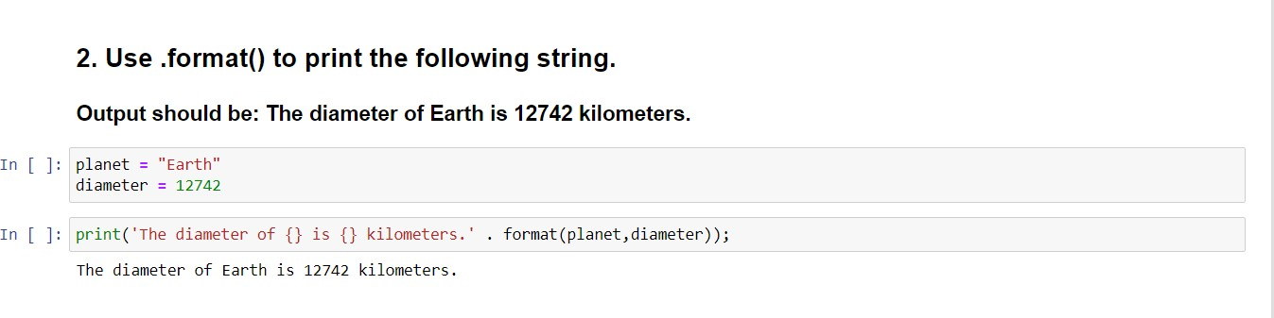

# Question-3:

In this nest dictionary grab the word “hello”

# Solution :

d = {'k1':[1,2,3,{'tricky':['oh','man','inception',{'target':[1,2,3,'hello']}]}]} d['k1'][3]['tricky'][3]['target'][3]

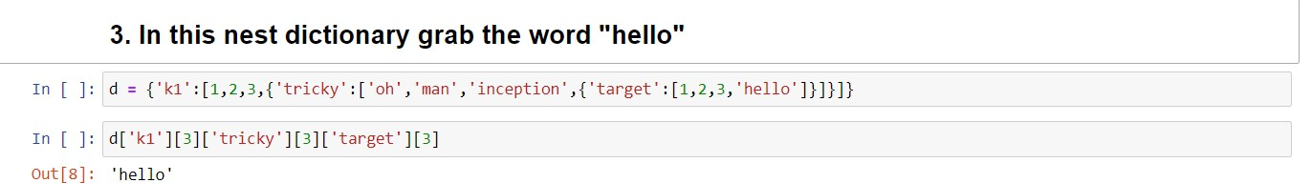

# Question-4:

* 1. Create an array of 10 zeros?
  2. Create an array of 10 Fives?

# Solution :

import numpy as np

* 1. a = np.zeros(10) a
  2. tmp=np.ones(10)*5 print(tmp)

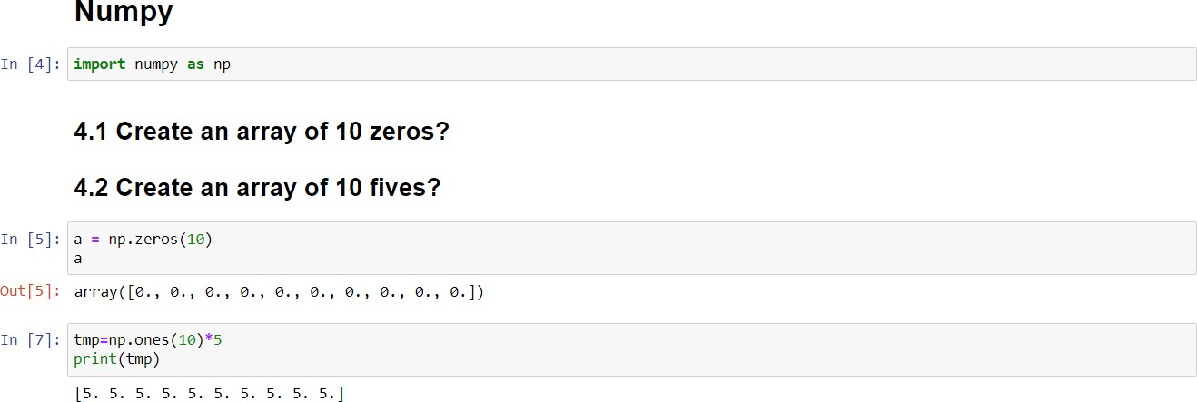

# Question-5:

Create an array of all the even integers from 20 to 35

# Solution :

print(np.arange(20,35,2))

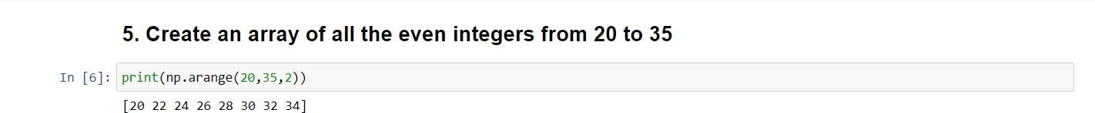

# Question-6:

Create a 3*3 matrix with values raging from 0 to 8

# Solution:

c = np.arange(0,9).reshape(3,3) c

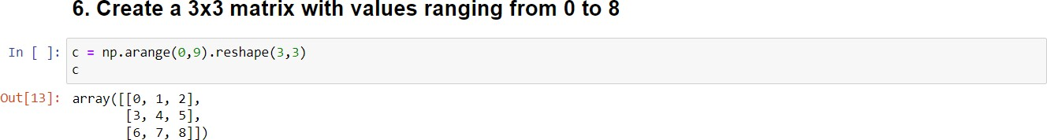

# Question-7:

Concatenate a and b

a= np.([1,2,3]), b=np.array([4,5,6])

# Solution:

a = np.array([1,2,3])

b = np.array([4,5,6]) np.concatenate((a,b),axis=0)

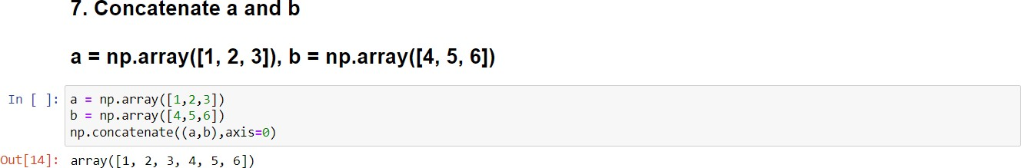

# Pandas Question-8:

Create a DataFrame with 3 rows and 2 columns

# Solution:

import pandas as pd

d = {"fruits":["mango","orange","apple"],"color":["yellow","orange","red"]} df = pd.DataFrame(d)

df

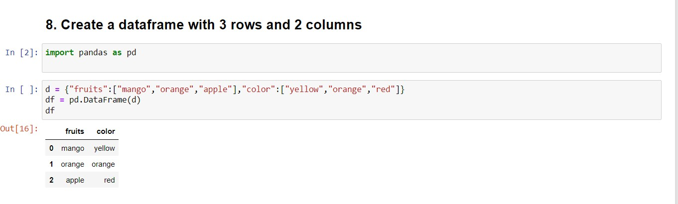

# Question-9:

Generate the series of dates from 1st Jan,2023 to 10th feb,2023

# Solution:

dates = pd.date_range(start='1/1/2023',end='2/10/2023') lists = []

for i in dates: lists.append(i.strftime('%d-%m-%y')) print(lists)

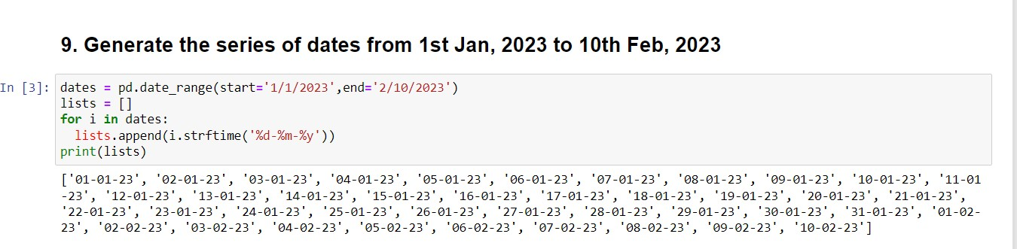

# Question-10:

Create 2D list to DataFrame

lists = [[1, 'aaa', 22], [2, 'bbb', 25], [3, 'ccc', 24]]

# Solution:

lists = [[1, 'aaa', 22], [2, 'bbb', 25], [3, 'ccc', 24]]

